**Heritage**

O illustrious endowments of sublime essence,

That amplify and reinforce our nation’s eminence.

The resplendent Taj glimmers to the vision of the night;

Solidifying ice at Amarnath renders a splendid sight.

The exquisite Khondalite art of the temple of Sun God,

And Hampi boasts of its ancient affluent abode.

The ascetic harsh penance at the Maha Kumbh Mela,

Furious martial illustrations at the Hola Mohalla,

From the walk of mettle on the scorching coal

To the euphonious cadence of the Tibetan toll.

These phenomenal spectacles revitalize our soul,

Preserving our heritage is our obligatory call.

-Aadityaamlan Panda

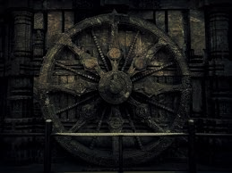

**Heritage**

O illustrious endowments of sublime essence,

That amplify and reinforce our nation’s eminence.

The resplendent Taj glimmers to the vision of the night;

Solidifying ice at Amarnath renders a splendid sight.

The exquisite Khondalite art of the temple of Sun God,

And Hampi boasts of its ancient affluent abode.

The ascetic harsh penance at the Maha Kumbh Mela,

Furious martial illustrations at the Hola Mohalla,

From the walk of mettle on the scorching coal

To the euphonious cadence of the Tibetan toll.

These phenomenal spectacles revitalize our soul,

Preserving our heritage is our obligatory call.

-Aadityaamlan Panda